**Topic-: MORSE CODE TRANSLATOR**

**A Project Report**

**LOVELY PROFESSIONAL UNIVERSITY PHAGWARA, PUNJAB**



## **Submitted to-: Mrs. Ankita Wadhawan**

## **Submitted By-:**

**Name of student Roll No. Registration**

Chintan Khatri Naveen Kumar 63 11915029

Sushant Sharma 01 11904963

Harsh Raj 31 11911220

**INTRODUCTION**

Our project deals with conversion of UPPERCASE English alphabets to Morse Code and vice-versa. We used Python and it’s libraries such as Tkinter to write the codes required.

*Morse code* is a method used in telecommunication to encode text characters as standardized sequences of two different signal durations, called dots and dashes or dits and dahs. *Morse code* is named after Samuel *Morse*, an inventor of the telegraph. ([source](https://en.wikipedia.org/wiki/Morse_code))

This project was very attractive to us as this method was very popular in old days for communication purpose and also good for data encryption. This method is still relevant for many radio transmissions and flight communications. It is also very nostalgic to us as we all have used Morse Code in our childhood for communication during a detective game. So, we really had a lot of fun making this.

**OBJECTIVE**

Our objective is to make a system that can encode UPPERCASE English alphabets and decode Morse code.

So we essentially had three things to do-:

1.Encoder code

2.Decoder code

3.GUI

By combining these we will get the product required.

**REQUIREMENTS**

We needed-:

1.Python 3.8

2.An IDE or any text editor

3.Tkinter

**PROCESS**

We divided our project as Encoder, Decoder and GUI. Then one person compiled them together and made changes after everyone’s agreement.

First we decided on GUI i.e it will take two inputs and inputs will have two options for language I.e Morse and English UPPERCASE.

We wanted to make a database for storing the morse code and alphabets values but we settled for python dictionary as it was faster to access and easier to make.

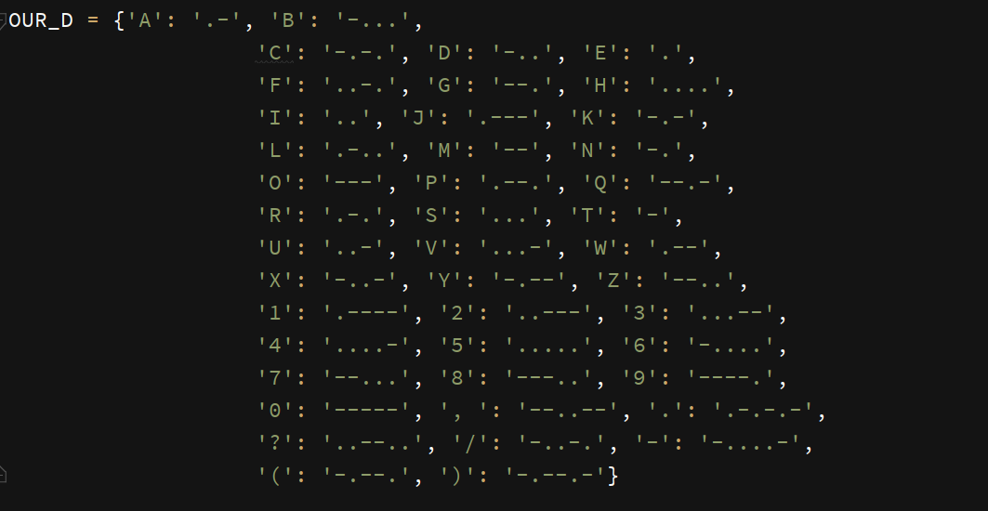

Then we made a DFD on the basis of our idea.

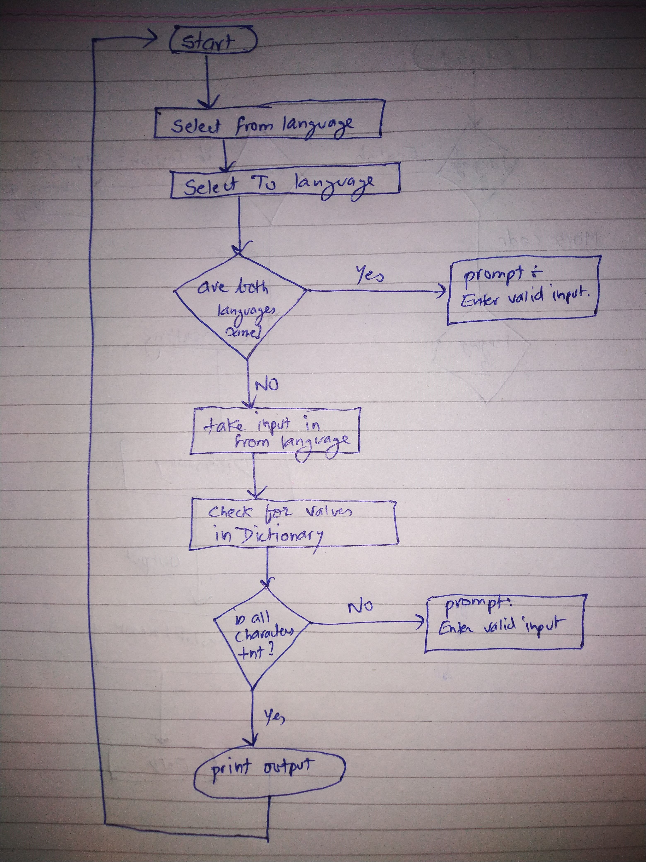

Then we made basic GUI for our project.

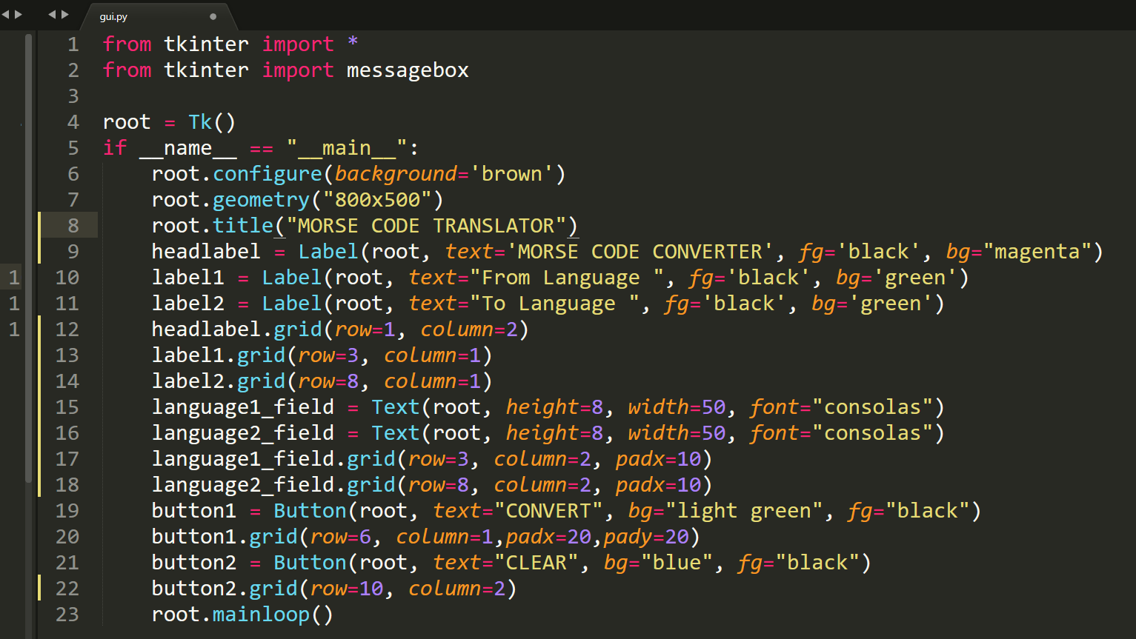

Gui essentially has two text fields for two languages and 5 buttons

Such as ‘convert,’ ‘clear’, ‘from language’ and ‘to language’.

And a heading.

Then we wrote codes for Encoder, which converts uppercase English alphabets to Morse code.

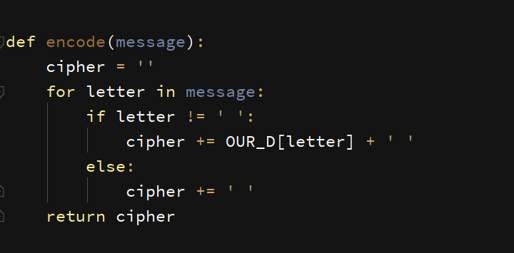

Working of Encode function:

Once a message is passed to this encode function, it first creates a temporary string cipher and iterates over all the characters of the message.

If the character of message is available in dictionary, it replaces that character with the value stored in dictionary and if the character is equal to space then it simply adds space in front of cipher.

After we have iterated through all the letters of message then we simply return out temporary string which now contains the translated version of input.

Then we made our Decode function:

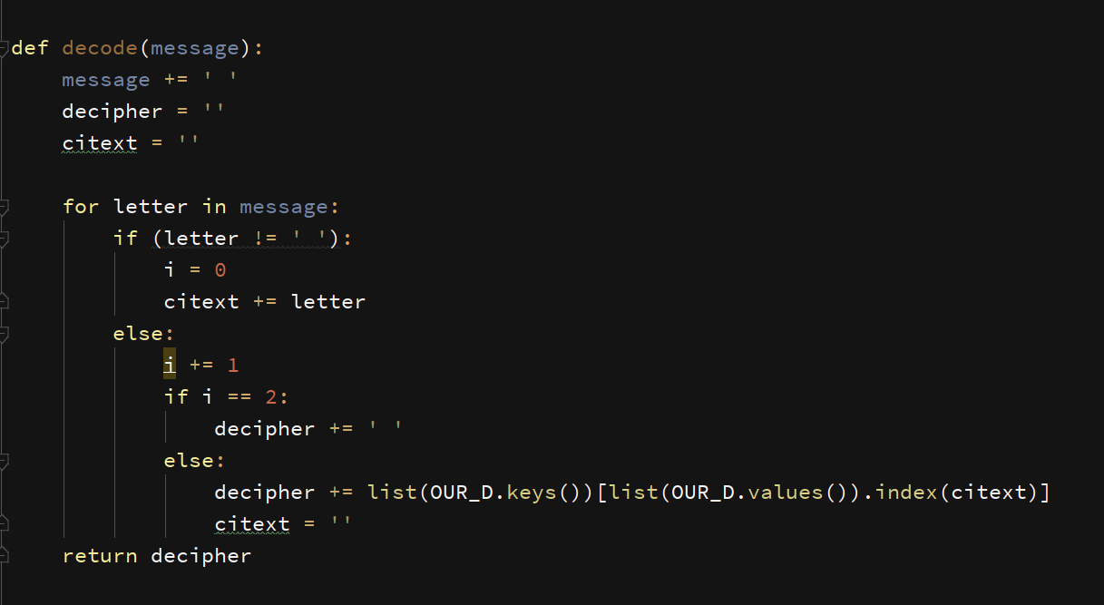

Working of Decode function:

We make two temporary string variables one to store final result and one to store words.

We add an extra space at the end of message which helps us in differentiate between a word and end of message.

We store characters in one string till we encounter a space and we decode that piece of characters by iterating over them and looking for their values in our morse code dictionary. And we save that value in decipher variable.And our previous variable is again set to default to store new piece of characters till it encounter two consecutive spaces.

Finally, we compiled all the functions and added buttons that allowed selection of language. And this was the outcome.

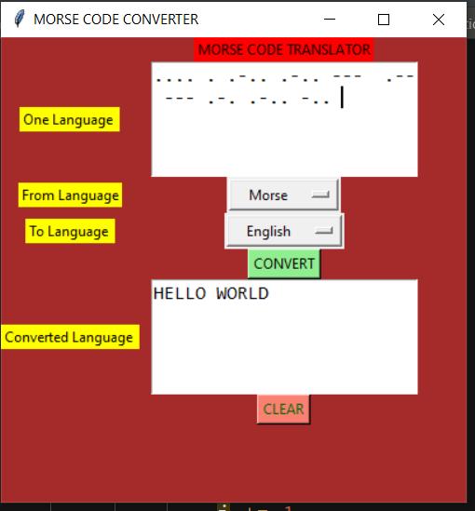

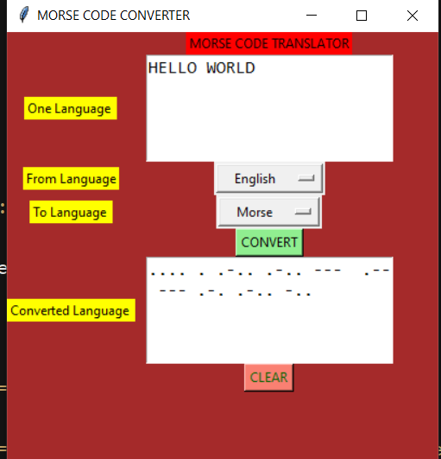

**OUTCOME**

1. We learned a lot about making projects in group and how to divide tasks equally, believe in our partners and how to communicate ideas with refinement so others could understand what the person wants.

2. This project really helped a lot in understanding the dimensions of Python and Tkinter for creating new projects and how to deal with problems that were not taught during classroom.

3. It gave us rough idea of how a commercial product is made and how much of detailing is required to make an idea run in the market.

4. We faced few issues with time management and bugs but we took help from [stackoverflow](https://stackoverflow.com/questions/22559290/tkinter-button-alignment-in-grid) and [tutorialspoint](https://www.tutorialspoint.com/python/python_gui_programming.htm) to get through those problems.

5. We learned the importance of making DFD and Flow chart of a project and the idea of division of a project into smaller modules.

6. Dividing project into smaller modules was really helpful as it can be easily changed and experimented with while writing a long piece of code was trippy and we have had many bugs in those codes.

7. This project was an eye opener for us regarding Object Oriented Programming methodology as it’s quite helpful when a bunch of people are working on the same project.

8. At last, we really enjoyed creating this program and it was very informative and memorable.